# Newsletter content

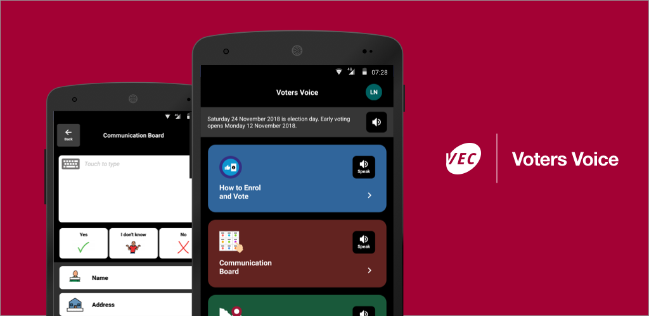

**Voters Voice – giving people with a disability a voice in the 2018 Victorian State election**

The Victorian Electoral Commission has enhanced its ground-breaking app designed to help people with a disability to participate in the Victorian State election on 24 November 2018.

Voters Voice is a free app to help people with complex communication needs vote in person at Victorian elections. The app also helps people with low literacy, English language difficulties and people who use Auslan.

**About the app**

The primary feature of the app is an electronic talking board for people who may not have, or who struggle with, speech. Custom voting phrases will assist them to vote in person at a voting centre.

Information about enrolling and voting is available in plain English, Easy English, audio, video and Auslan. The app also includes a voting centre locator and can provide directions to the nearest early voting centre or election day voting centre.

Text-to-speech capability ensures that the text on all aspects of the app (except for the map) can be read out loud. Text within the communication board can be read or shown.

Please note:

* the app does not contain information on candidates standing in the election
* the app cannot be used to cast a vote.

Further information about the app can be found online at [vec.vic.gov.au/votersvoice/](https://www.vec.vic.gov.au/votersvoice/)

**Download**

Voters Voice is available for use on tablets and smart phones on iOS and Android operating systems.

cid:image005.png@01D4396A.59B02660   
App Store: <https://itunes.apple.com/au/app/voters-voice/id1140391321?mt=8>

cid:image006.png@01D4396A.59B02660  
Google play: <https://play.google.com/store/apps/details?id=au.gov.vic.vec.votersvoice>

**Website content**

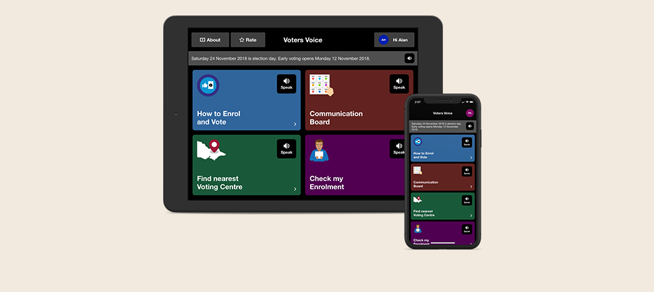

**Voters Voice**

Voters Voice is a **free** app, developed by the Victorian Electoral Commission. It is designed to help people participate in the 2018 Victorian State election on Saturday 24 November if they:

* have complex communication needs
* have low literacy
* have low English language ability
* use Auslan.

**Features**

The primary feature of the app is an electronic talking board for people who may not have, or who struggle with, speech. Custom voting phrases will assist them to vote in person at a voting centre.

Information about enrolling and voting is available in plain English, Easy English, audio, video and Auslan. The app also includes a voting centre locator and can provide directions to the nearest early voting centre or election day voting centre.

Text-to-speech capability ensures that the text on all aspects of the app (except for the map) can be read out loud. Text within the communication board can be read or shown.

Please note:

* the app does not contain information on candidates standing in the election
* the app cannot be used to cast a vote.

**Download**

Voters Voice is available for use on tablets and smart phones on iOS and Android operating systems.

cid:image005.png@01D4396A.59B02660   
App Store: <https://itunes.apple.com/au/app/voters-voice/id1140391321?mt=8>

cid:image006.png@01D4396A.59B02660  
Google play: <https://play.google.com/store/apps/details?id=au.gov.vic.vec.votersvoice>

# Social Media content

**Twitter**

Voters Voice is a free app to help voters with complex communication needs participate in the 2018 Victorian State election. It has info on how to enrol, and where to find a voting centre. Get it on Google Play: [http://ow.ly/WQKZ30llBRG](https://l.facebook.com/l.php?u=http%3A%2F%2Fow.ly%2FWQKZ30llBRG&h=AT36fey3pFPPY1ITKHO_KqkWlRyuGDjlocLgD3E7TYdf3KkDsnTeRzH5c1EOaPlDb_d2S6qbU_R0he8Ql3vTWhEo8F-rS7mNmI3LH57u4HZVgM406HWq8QfIak7NycYjWMMwqMi58uyCpN6QFD2LmGz9-ygKopx3sd2d0yj6wF4EITbkyOfjActygj7HVRAVmjatI1A3RQsQBg0vKCep8b2N0Vt-c9_xRSCEHn-neQ5c-iyaTg8ng_cLe5V5GMkZn3x73tmpHdHDFb__bYDQRq7yJJjpYLxGvW4166bFn-xKz1GeNhYHRq6fG3qW18LXBqmlmvqqUHXjc3uZ1ddA5ge2TnI2x-iE-g) or iTunes: <http://ow.ly/zvBO30llBS6> [#Vicvotes](https://business.facebook.com/hashtag/vicvotes?source=feed_text&__xts__%5B0%5D=68.ARAQyu43TWvP3Cu7lGkpc1PwvHrDkooANxvyk68XjHw_TLqVPHHTzQLKlV8-PtikGgvfsT8394eMzOFLv5JrdSlX6UDd6cE24iBFyz3zOpdScIopx-zBhiakzHvEjidWUGGdrlc&__tn__=K-R)

**Facebook:**

Check out the Victorian Electoral Commission’s free new app, Voters Voice, designed to help people with low literacy, English language difficulties, who are deaf, or have a hearing or speech impairment to be able to have their say at the State election on Saturday 24 November. Get it on Google Play: [http://ow.ly/WQKZ30llBRG](https://l.facebook.com/l.php?u=http%3A%2F%2Fow.ly%2FWQKZ30llBRG&h=AT36fey3pFPPY1ITKHO_KqkWlRyuGDjlocLgD3E7TYdf3KkDsnTeRzH5c1EOaPlDb_d2S6qbU_R0he8Ql3vTWhEo8F-rS7mNmI3LH57u4HZVgM406HWq8QfIak7NycYjWMMwqMi58uyCpN6QFD2LmGz9-ygKopx3sd2d0yj6wF4EITbkyOfjActygj7HVRAVmjatI1A3RQsQBg0vKCep8b2N0Vt-c9_xRSCEHn-neQ5c-iyaTg8ng_cLe5V5GMkZn3x73tmpHdHDFb__bYDQRq7yJJjpYLxGvW4166bFn-xKz1GeNhYHRq6fG3qW18LXBqmlmvqqUHXjc3uZ1ddA5ge2TnI2x-iE-g) or iTunes: <http://ow.ly/zvBO30llBS6> [#Vicvotes](https://business.facebook.com/hashtag/vicvotes?source=feed_text&__xts__%5B0%5D=68.ARAQyu43TWvP3Cu7lGkpc1PwvHrDkooANxvyk68XjHw_TLqVPHHTzQLKlV8-PtikGgvfsT8394eMzOFLv5JrdSlX6UDd6cE24iBFyz3zOpdScIopx-zBhiakzHvEjidWUGGdrlc&__tn__=K-R)